Architecture / Technology

for "t-Health" web application
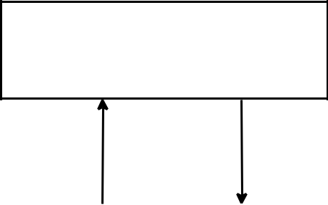

Client

(JSP Web Application )

Response
Request
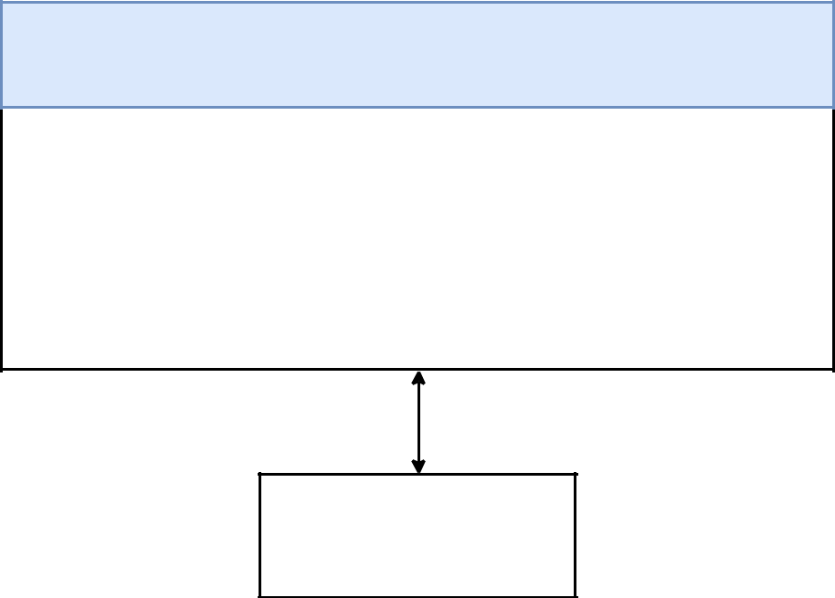

Server (Servlet)

Controller |  | Service |  | DAO

DBMS

(Mysql)

Back of the Envelope Calculation
- Targeted number of users : 10 ,000
- Targeted Geographical location of users : Fairfield, United States of America
- Manpower skillset required
  - 1 front end
  - 1 backend
  - 1 devops
  - 1 system analyst
  - 1 quality Assurance
- Development time span: 2 days
- Memory allocation
  - Patient record Storage: 5MB
  - System Minimum Storage (User storage (5MB) * targeted users (10,000)): 50GB
- Users peak time: 8:00AM - 4:30 PM
- Platform targeted: Web
- Scalability plans:
  - Moving from ORM database system (Mysql) to NoSql (SQL Graph)
  - Deployment of more servers
- CAP Theorem Compliance: Consistence and Availability

